**Depot Capacity**

***Work-flow to Use Duty Types***

Use **Add Preference** to obtain a baseline dialog that sets Duty Types



Repeat **Add Preference** for additional instances of the baseline dialog



***Preference Overview***

This preference defines depot locations and there parking capacity, whether global or by

Vehicle Type.

***Add Preference Dialog***

**Prerequisites:** None.

**Opening Dialog:**

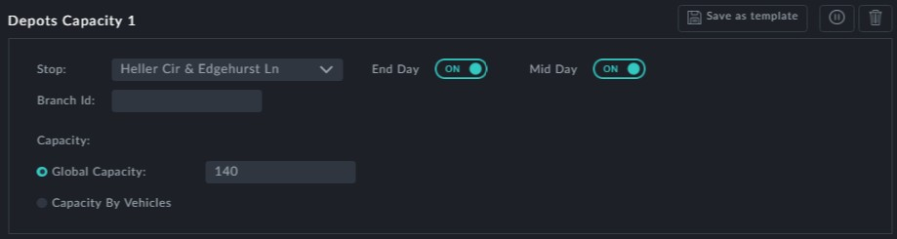

**Points to note:**

**Stops**: Stops is a drop down list of stops that can be used as "depots". You may only choose one.

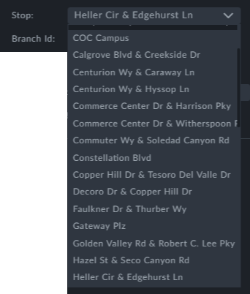

Use **Add preferences** again to add further stops as depots.



The **End Day** and **Mid Day** switches: These determine whether the chosen stop can



be used as an end-day and/or mid-day depot

**Branch ID** is an optional depot name or ID of your choice



**Capacity** is the number of vehicles that may be parked in the depot. You have a choice between -



**Global Capacity**: A single figure vehicle capacity



**Capacity by Vehicles**

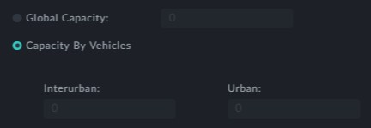

Yo may enter vehicle capacity by Vehicle Type



Vehicle Type is customer defined. You will see your own Vehicle Types here.